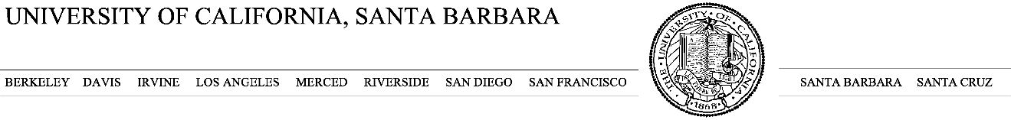

Ana Miller-ter Kuile

E-mail: ana.miller-ter.kuile@lifesci.ucsb.edu

Tel: 719-580-1002

June 16, 2020

To the editors of *Molecular Ecology Resources*:

Enclosed, please find a manuscript my co-authors and I believe would be ideally suited for *Molecular Ecology Resources*. In this article, entitled, “Effects of environmental contamination on diet DNA metabarcoding data of invertebrate consumers in mesocosms and natural environments”, we present results from a surface sterilization treatment of invertebrate consumers prior to DNA metabarcoding aimed at exploring the effects of surface contaminants on diet DNA data. We believe this study directly relates to the scope of *Molecular Ecology Resources* by providing validation and improvement of DNA metabarcoding as a molecular tool for diet studies across taxa in a wide range of environmental contexts.

Our findings provide evidence from several terrestrial environmental contexts that surface contamination does not systematically alter DNA metabarcoding-derived diet data, but that in a contained, mesocosm environment, surface contaminants from shared space with a diet item could inflate estimates of consumption. We believe this study to be timely and of general interest as DNA metabarcoding continues to provide valuable insight into a range of consumptive interactions in invertebrate consumers (e.g. host-parasitoid, predator-prey, consumer-fungus). However, the field has not addressed the potential problem of environmental contamination and systematic fixes (e.g. surface sterilization). In addition to the findings in this study, we use our results to provide general guidelines for DNA metabarcoding studies of invertebrate consumers going forward, including environmental, ecological, and methodological contexts in which surface contaminants may influence diet data.

The work in this manuscript is all original research carried out by the authors and all authors agree to its content. We acknowledge all research not carried out by the authors in this manuscript. Furthermore, we acknowledged all sources of funding and declared any direct financial benefits that could result from publication. We received appropriate approvals to conduct this research. The results in this manuscript have not been submitted for publication elsewhere, nor are they previously published.

We look forward to hearing your thoughts on this work. Please feel free to contact me with any questions about this material. On behalf of my co-authors, I thank you for your consideration of our submission.

Sincerely,

Ana Miller-ter Kuile